Assessment: Lab Exam 2

Student Name: Zahi Masarwa

Lab Professor Name: Mel Sanschagrin

Lab Section Number: 303

Due Date: 04/13/21

# Understand the problem

This program is going to input the number of kilometres that is going to be drive between the distances that the person is planning to drive and calculate them in this way:

The distance divided by (100 km and by fuel efficiency of car)

Then the result will be printed on the screen

# Pseudocode

Start

Declare class Milageuseage;

Declare double fuelefficiency, distance;

Output “Please enter the distance that will be driven:”

Input distance;

Output “Please enter fuel efficiency”

Input fuelefficiency;

Use Milageuseage class to calculate gas needed for trip

End

Start Milageuseage;

Declare private double distance;

Declare private double fuelefficiency;

Declare private int fueleperkm=100;

Public Milageuseage();

Public double getdistance(){

Return distance

}

Public double getfuelefficie(){

Return fuelefficiency

}

Public void setcar(declare double distance, declare double fuelefficiency){

Distance= distance;

Fuelefficiency= fuelefficiency;

}

Public void caculateefficncy(){

Declare double result;

Output result;

}

end

# Flowchart

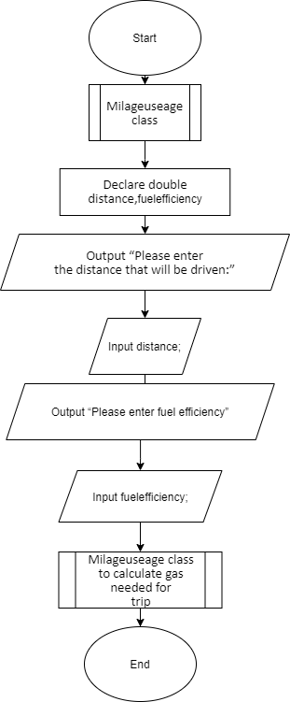

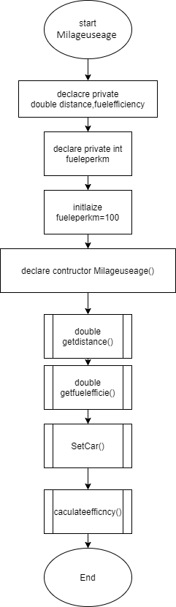

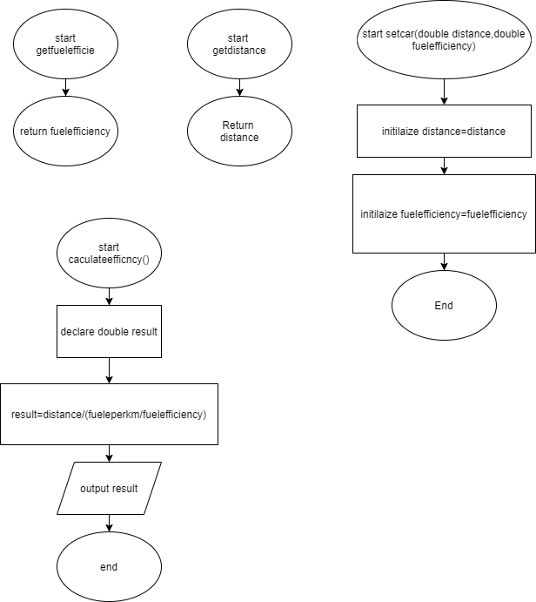

# UML

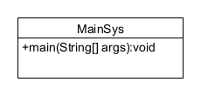

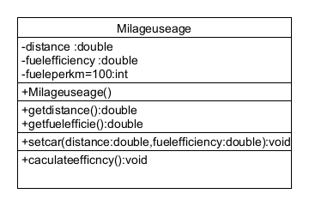

# Test Algorithm with Simple Input

|  |  |  |  |
| --- | --- | --- | --- |
| Input | Expected Output | Output | Description |
| 900,6.8 | 61 | 61 | The result has been calculated and output 61 |
| A,6.8 | Error | Error | because I entered string I got an error in output |

# Compile and Run Your Program

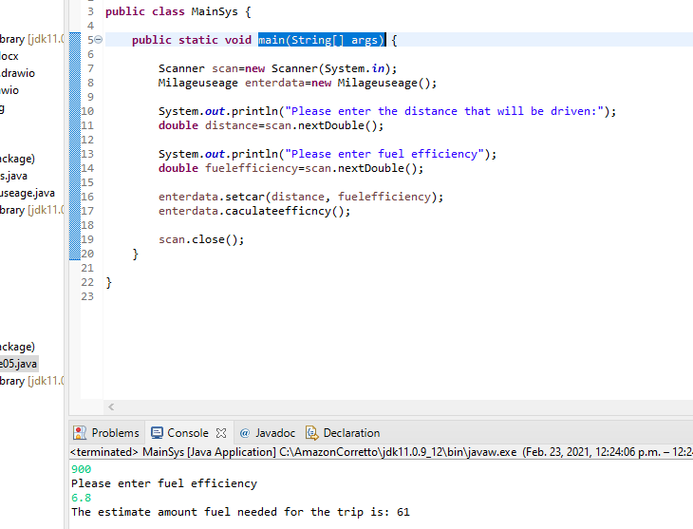

# Test Your Program

|  |  |  |  |
| --- | --- | --- | --- |
| Input | Expected Output | Output | Description |
| 900,6.8 | The estimate amount fuel needed for the trip is: 61 | The estimate amount fuel needed for the trip is: 61 | The result has been calculated and output 61 |
| A,6.8 | Error | Error | because I entered string, I got an error in output |